Clustering

Marco Antonio Cuellar Retamozo

2024-05-26

Introduction to the Problem
The dataset presented provides valuable insights into the distribution of stock ownership across diverse industry sectors within the American economy. It offers a comprehensive overview of the average percentage of stock holdings attributed to various institutional entities, thereby shedding light on the intricate dynamics of investment within the market:
'data.frame': 94 obs. of 5 variables:
$ Industry Name : chr "Advertising" "Aerospace/Defense" "Air Transport" "Apparel" ...
$ CEO Holding : num 0.0562 0.0286 0.0772 0.0642 0.0582 ...
$ Corporate Holdings : num 0.1486 0.0753 0.1194 0.0165 0.0845 ...
$ Institutional Holdings: num 0.343 0.486 0.413 0.49 0.254 ...
$ Insider Holdings : num 0.159 0.106 0.18 0.172 0.115 ...
Take a look at the meaning of these variables:
- CEO Holding: This refers to the stock held by the Chief Executive Officer (CEO) of companies within an industry. A larger holding indicates that the CEO's interests align with those of stakeholders and the company itself.
- Corporate Holding: These are the stocks held by other companies across various sectors. They are acquired for reasons such as expanding into related sectors, diversifying portfolios, attempting to gain significant influence in other companies' decision-making, or protecting against hostile takeovers.
- Institutional Holdings: These represent stocks held by organizations that make substantial investments in financial markets. They typically encompass banks, pension funds, mutual funds, hedge funds, insurance companies, sovereign wealth funds, and other comparable financial entities.
- Insider Holding: This refers to the percentage of a company's shares held by individuals or entities internal to the company itself.
Our objective is to utilize clustering techniques to categorize industry sectors based on these variables. By doing so, we aim to identify distinct patterns and gain valuable insights into how stock ownership is distributed among the different entities under consideration.

Method
The first algorithm we will examine is based on divisive methods: the Partitioning Around Medoids (PAM) algorithm. This algorithm, using a quality criterion to determine the optimal number of groups, selects the most central unit as the medoid of each group. It then iteratively adds the nearest units to the group, repeating the process until the medoids remain unchanged.
As previously mentioned, we employ several methodologies to validate the correct number of groups we should use. These methodologies are based on "internal indices," so called because they do not rely on external information to assess the quality of the partitioning. Some of these indices include:
The Elbow Method, which shows how the within-cluster variance increases with different numbers of groups. The Silhouette Index, which is similar to the first index but normalizes the variance by the number of units and groups.

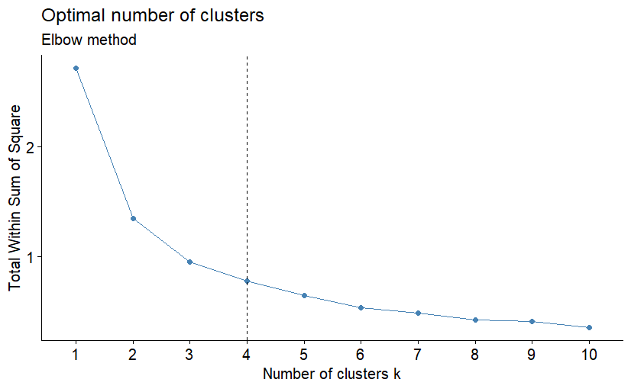

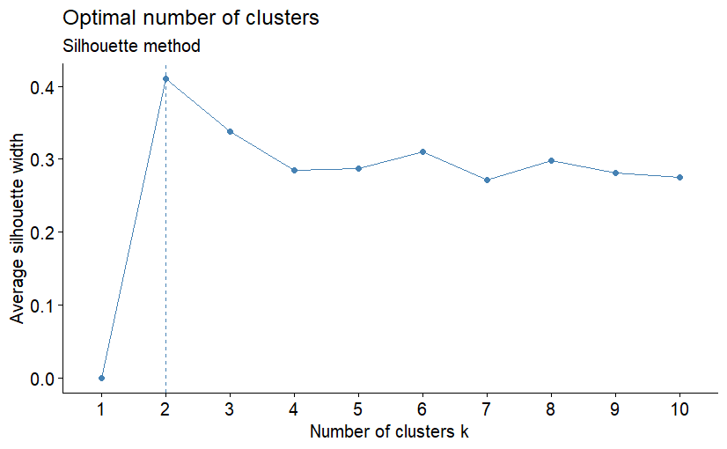
*******************************************************************
* Among all indices:
* 8 proposed 2 as the best number of clusters
* 6 proposed 3 as the best number of clusters
* 1 proposed 4 as the best number of clusters
* 1 proposed 6 as the best number of clusters
* 1 proposed 7 as the best number of clusters
* 1 proposed 8 as the best number of clusters
* 1 proposed 10 as the best number of clusters
* 1 proposed 11 as the best number of clusters
* 3 proposed 15 as the best number of clusters
***** Conclusion *****
COMMENT: It is common for different methods to produce different optimal cluster numbers because of their different approaches. Often, it is useful to interpret the results of both methods together, also considering domain knowledge and the goal of the analysis. The number of clusters we chose was 3.
-We did not choose 4 because one of the clusters contained too few observations, which could be simply linked to another group, and also because this 4th cluster did not provide any explanatory information relevant to our analysis.
-We did not use 2 clusters either because the resulting split was too general and did not provide specific enough information for our purposes.

PAM
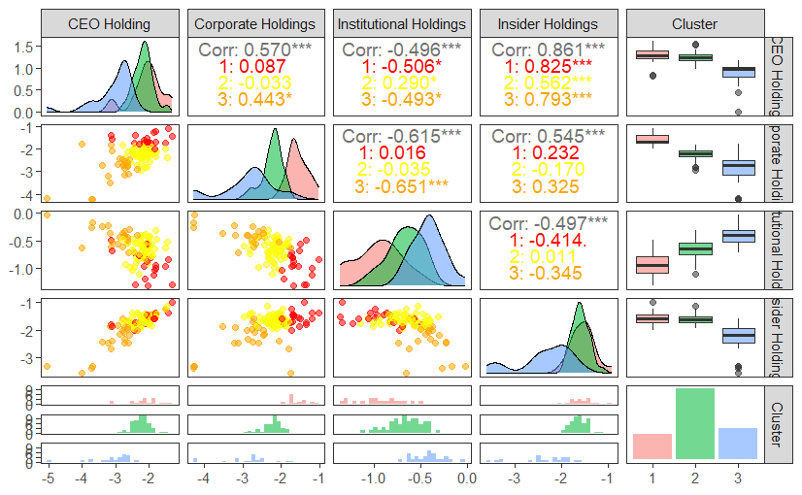
COMMENT: We can appreciate how the algorithm has successfully performed clustering for each variable, allowing us to make several observations:
-The correlation between CEO holdings and Insider holdings is quite high. The clustering that includes both variables does not entirely separate the realizations well, especially in the upper part where there are clusters with a medium and high tendency to acquire shares. This issue is not present when the holdings are low.
-There is a positive correlation between CEO holdings and corporate holdings. This may indicate that when CEO's tend to hold a high amount of shares in their companies, other corporate groups increase their tendency to purchase a higher number of shares in those companies as well, and viceversa. The group division is quite effective; we can see groups where both the CEO holds a significant amount of shares, indicating market confidence, which in turn motivates corporate acquisitions, and viceversa.
-A negative correlation is observed between CEO holdings and institutional holdings, as well as between corporate holdings and institutional holdings. This indicates that when a CEO or corporate entities tend to acquire a larger number of shares, financial entities tend to invest less in the shares of companies in those sectors. This may be because financial entities tend to make significant investments with a logic aimed at short-term gains. Although there may be pension funds in this group, the number of financial entities on the other side of the balance more than reverses the trend, focusing on high-risk products in an attempt to achieve potentially higher returns.
In the first case, the clustering is not as "clean" as in the second case. This may be due to some financial entities being more than willing to invest in solid companies, which does not occur in the second group. I assume this is because the number of reasons why corporate groups might increase their holdings are many and do not necessarily indicate a solid company.
-The boxplots, on the other hand, represent the same variables across different clusters. It can be observed that for Institutional and Corporate holdings, there is a clearer distinction among the units within the clusters. The boxplots show divergences in the mean values and more pronounced dispersions within the clusters. These variables effectively capture the different characteristics between the clusters, resulting in better differentiation. This distinction is also evident when comparing them, as noted in the previous analysis.
Below we can observe one of the results of the classified sectors, with the clustering carried out through the algorithm, which specifically relates to clustering according to the variables Corporate holding and Institutional holding mentioned earlier in the analysis, which was chosen because it was fairly representative and well differentiated on the groups.

CLUSTER | Industry_Name
Group 1  (19) | Advertising, Air Transport, Auto & Truck, Beverage (Soft), Cable TV, Chemical (Basic), Electronics (Consumer & Office), Entertainment, Investments & Asset Management, Metals & Mining, Office Equipment & Services, Precious Metals, Real Estate (Development), Real Estate (Operations & Services), Recreation, Shipbuilding & Marine, Software (Entertainment), Telecom (Wireless), Tobacco
Group 2  (52) | Aerospace/Defense, Apparel, Auto Parts, Banks (Regional), Beverage (Alcoholic), Broadcasting, Brokerage & Investment Banking, Business & Consumer Services, Chemical (Specialty), Coal & Related Energy, Computer Services, Computers/Peripherals, Construction Supplies, Drugs (Biotechnology), Drugs (Pharmaceutical), Education, Electrical Equipment, Electronics (General), Engineering/Construction, Environmental & Waste Services, Farming/Agriculture, Financial Svcs. (Non-bank & Insurance), Food Processing, Furn/Home Furnishings, Green & Renewable Energy, Healthcare Products, Healthcare Support Services, Heathcare Information and Technology, Homebuilding, Hotel/Gaming, Household Products, Information Services, Insurance (General), Insurance (Prop/Cas.), Oil/Gas (Production and Exploration), Oil/Gas Distribution, Oilfield Svcs/Equip., Real Estate (General/Diversified), Restaurant/Dining, Retail (Automotive), Retail (Building Supply), Retail (Distributors), Retail (General), Retail (Grocery and Food), Retail (Special Lines), Rubber& Tires, Software (Internet), Software (System & Application), Telecom. Equipment, Telecom. Services, Transportation, Trucking
Group 3  (23) | Bank (Money Center), Building Materials, Chemical (Diversified), Diversified, Food Wholesalers, Hospitals/Healthcare Facilities, Insurance (Life), Machinery, Oil/Gas (Integrated), Packaging & Container, Paper/Forest Products, Power, Publishing & Newspapers, R.E.I.T., Reinsurance, Retail (REITs), Semiconductor, Semiconductor Equip, Shoe, Steel, Transportation (Railroads), Utility (General), Utility (Water)
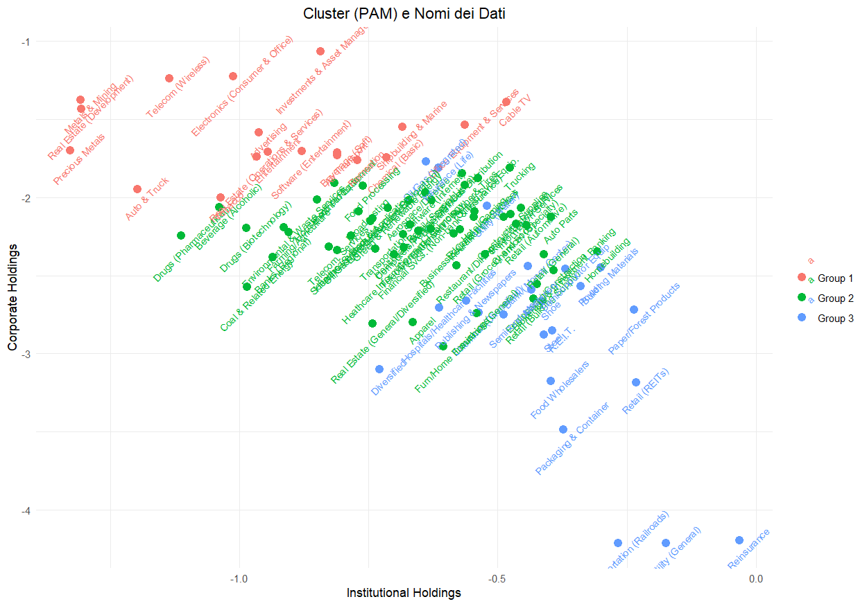

COMMENT: We can appreciate that the more "stable" sectors, where companies participate substantially, belong to the first group, which includes industries such as aerospace, precious metals, and real estate. These are plausibly considered "safe haven" sectors or those where assets tend to appreciate. In stark contrast, in the third group, where financial institutions invest to achieve good returns, the prominent sectors include banking, Insurance (Life), construction materials, oil and gas, semiconductors, and others.
- DENDOGRAM
This algorithm is based on a hierarchical method, taking the form of an inverted tree, where all the units emerge from the root. Its advantage lies in showing different partitions of the units at various levels, eventually reaching the singular units. The decision on how to group these units is made by cutting the tree at a specific level.
To determine where to cut the tree, it is useful to define the distance measures between the groups. If the distance is Euclidean, as in this case, the method used for the division (Ward's method) relies on an analysis of the relationship between the increase in the between-group variance (Between) to divide the groups if it increases significantly, and the reduction in the within-group variance (Within) to achieve

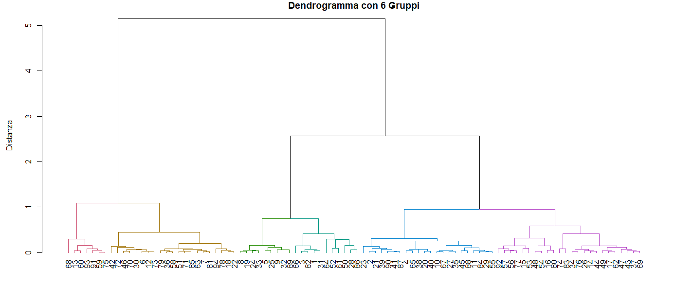
homogeneous groups

COMMENT: Thanks to the reduction of the within-group variance, an appropriate number of groups that can be identified using this technique is 4, although we have considered 6 groups for analysis purposes. This method, in terms of interpretation, is different from the one previously discussed, as it uses all the variables with equal weighting to then proceed with the determination of the groups.
This approach, unlike the previous one, resulted in fairly homogeneous groups in terms of industries, as hypothesized, since our analysis variables are not being compared.
CLUSTER | Industry_Name
1 (11) | Advertising, Air Transport, Electronics (Consumer & Office), Entertainment, Investments & Asset Management, Metals & Mining, Precious Metals, Real Estate (Development), Real Estate (Operations & Services), Software (Entertainment), Telecom (Wireless)
2 (22) | Aerospace/Defense, Apparel, Beverage (Soft), Broadcasting, Computer Services, Computers/Peripherals, Diversified Electrical Equipment, Electronics (General), Food Processing, Green & Renewable Energy, Healthcare Products, Healthcare Support Services, Heathcare, Information and Technology, Household Products, Oil/Gas (Production and Exploration), Real Estate (General/Diversified), Recreation Software (System & Application), Telecom. Equipment Telecom. , Services Transportation
3 (9) | Auto & Truck, Banks (Regional), Beverage (Alcoholic), Coal & Related Energy , Drugs (Biotechnology), Drugs (Pharmaceutical), Environmental & Waste Services, Farming/Agriculture Tobacco
4 (21) | Auto Parts, Bank (Money Center), Brokerage & Investment, Banking , Chemical (Specialty) , Construction Supplies, Engineering/Construction, Food Wholesalers, Homebuilding, Information Services, Machinery Packaging & Container, R.E.I.T. Retail (Automotive), Retail (Building Supply), Retail (Distributors), Retail (General), Semiconductor, Semiconductor Equip, Shoe Steel, Utility (Water)
5 (7) | Building Materials, Paper/Forest, Products, Power, Reinsurance Retail (REITs), Transportation (Railroads), Utility (General)
6 (24) | Business & Consumer Services, Cable TV, Chemical (Basic), Chemical (Diversified), Education, Financial Svcs. (Non-bank & Insurance), Furn/Home, Furnishings Hospitals/Healthcare, Facilities Hotel/Gaming, Insurance (General), Insurance (Life), Insurance (Prop/Cas.), Office Equipment & Services Oil/Gas, (Integrated) Oil/Gas, Distribution Oilfield Svcs/Equip., Publishing & Newspapers, Restaurant/Dining, Retail (Grocery and Food), Retail (Special Lines), Rubber& Tires, Shipbuilding & Marine Software (Internet), Trucking
COMMENT: Within these 6 groups, some macro-sectors can be easily recognized, such as:
- Aerospace industry, metals, real estate
- Healthcare, computing electronics/information technology/software
- Pharmaceutical/waste services, tobacco/alcohol for consumption
- Banking/investments, construction/chemical supplies/engineering/homebuilding/retail building supply
- Could be linked to group 4
- Facilities for home/hotels, services for home/offices/schools (gas/food, grocery/education)

MODEL BASED ALGORTIMH
According to this parametric approach compared to the previous ones, cluster analysis consists of finding (hidden) parameters, in the different possible groups to which the units belong (probabilistic cluster), the latter being representable as a distribution on the data space, which can be mathematically described using a probability density function, i.e., a distribution.
It is evident that from such an approach it will be necessary to estimate parameters that characterize the distribution in question, in an iterative manner in order to assign the units most likely to the different instances to which they might belong.

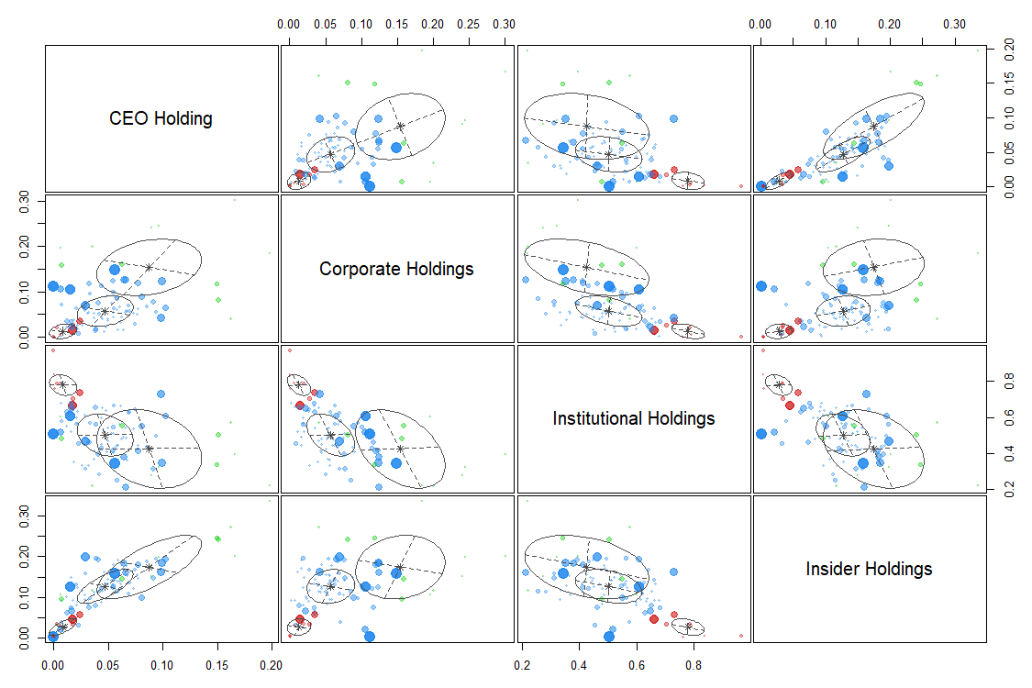

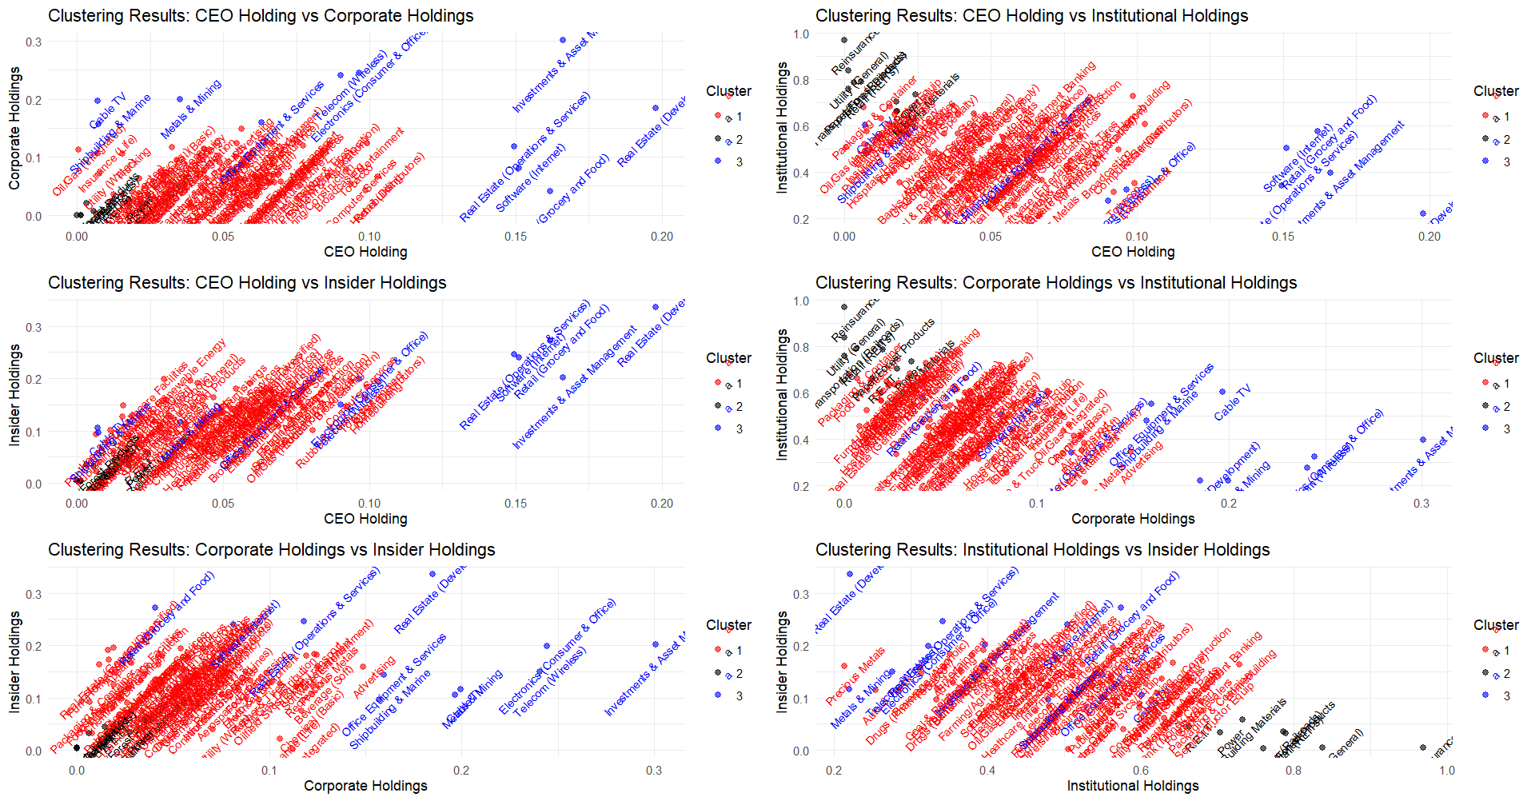
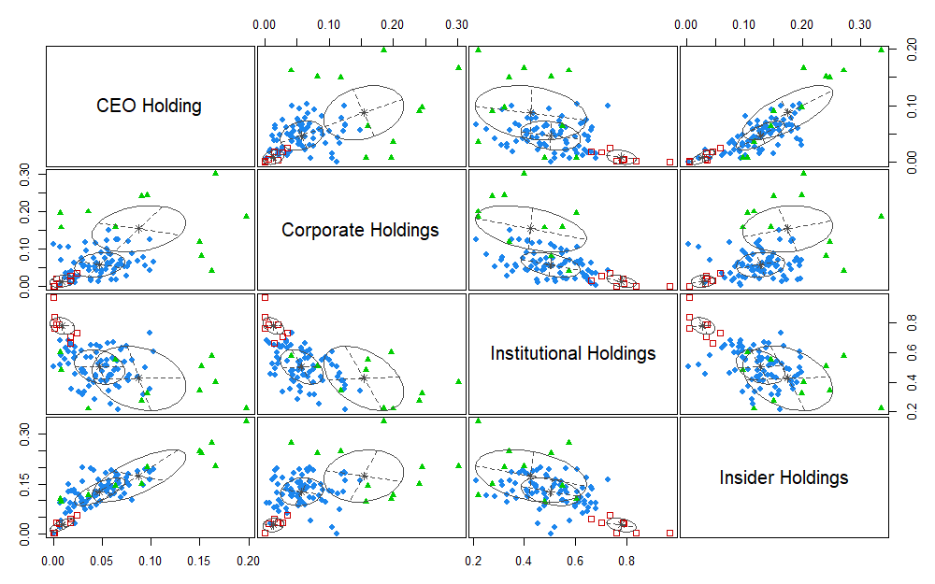

CLUSTER | Industry_Name
1(74) | Advertising, Aerospace/Defense, Air Transport, Apparel, Auto & Truck, Auto Parts, Bank (Money Center), Banks (Regional), Beverage (Alcoholic), Beverage (Soft), Broadcasting, Brokerage & Investment Banking, Business & Consumer Services, Chemical (Basic), Chemical (Diversified), Chemical (Specialty), Coal & Related Energy, Computer Services, Computers/Peripherals, Construction Supplies, Diversified, Drugs (Biotechnology), Drugs (Pharmaceutical), Education, Electrical Equipment, Electronics (General), Engineering/Construction, Entertainment, Environmental & Waste Services, Farming/Agriculture, Financial Svcs. (Non-bank & Insurance), Food Processing, Food Wholesalers, Furn/Home Furnishings, Green & Renewable Energy, Healthcare Products, Healthcare Support Services, Heathcare Information and Technology, Homebuilding, Hospitals/Healthcare Facilities, Hotel/Gaming, Household Products, Information Services, Insurance (General), Insurance (Life), Insurance (Prop/Cas.), Machinery, Oil/Gas (Integrated), Oil/Gas (Production and Exploration), Oil/Gas Distribution, Oilfield Svcs/Equip., Packaging & Container, Precious Metals, Publishing & Newspapers, Real Estate (General/Diversified), Recreation, Reinsurance, Restaurant/Dining, Retail (Automotive), Retail (Building Supply), Retail (Distributors), Retail (General), Retail (Special Lines), Rubber& Tires, Semiconductor, Semiconductor Equip, Shoe, Software (Entertainment), Software (System & Application), Steel, Telecom. Equipment, Telecom. Services, Tobacco, Transportation, Trucking, , Utility (Water)
2(8) | Building Materials, Paper/Forest Products, Power, R.E.I.T.s, Transportation (Railroads), Utility (General), Reinsurance, Retail (REITs), Utility (General)
3(11) | Cable TV, Electronics (Consumer & Office), Investments & Asset Management, Metals & Mining, Office Equipment & Services, Real Estate (Operations & Services), Retail (Grocery and Food), Software (Internet), Shipbuilding & Marine, Telecom (Wireless), Real Estate (Development), Retail (REITs)

COMMENT: I can say that the results found tend to be similar to those found with PAM. The correlations are as we said before. However, the number of units decreases in the first or third group, compared to the scissor clustering approach.
But the most striking classifications remain the same, for example, if we take Institutional Holding versus Corporate Holding, we always have that sectors such as Real State, precious metals, communications, the electronics sector remain value investment targets and so much the subject of Corporate, while the sectors of transportation, highway construction, construction materials, paper and some utilities remain volatile sectors that period where Institutional Holding made a profit

Conclusion
To affirm at least that such years the phenomenon of holdings in corporate holdings was essentially so, we should go to the statistics of the year under investigation:
In 2023, the sectors in which financial entities in the United States have the most holdings include technology, financial services, healthcare, and energy. Specifically, the software, data services, and wireless telecommunications industries stand out in the technology sector. Additionally, financial entities also invest significantly in the energy sector, particularly in oil and gas extraction (MarketBeat) (Visual Capitalist).
I can conclude that PAM algorithm has done a more accurate job in identifying sectors related to true statistics. Although because of the size of business done there may also be many sectors that are not pressed into consideration by the media

